**Exercise 3 - AAA Fixtures and Setup**

**Objective:**

To learn how to apply the **Arrange-Act-Assert (AAA)** pattern in unit testing and use @BeforeEach to initialize test objects before each test.

**Steps Followed:**

1. Created a Calculator class with add() and subtract() methods.
2. Created a test class CalculatorTest.
3. Used the **AAA pattern**:
   * **Arrange:** Setup test data or objects
   * **Act:** Call the method being tested
   * **Assert:** Check the expected result
4. Used @BeforeEach method to initialize the Calculator before every test.

**Java Code:**

**Calculator.java**

public class Calculator {

public int add(int a, int b) {

return a + b;

}

public int subtract(int a, int b) {

return a - b;

}

}

**CalculatorTest.java**

import org.junit.jupiter.api.BeforeEach;

import org.junit.jupiter.api.Test;

import static org.junit.jupiter.api.Assertions.*;

public class CalculatorTest {

private Calculator calculator;

@BeforeEach

public void setUp() {

calculator = new Calculator(); // Arrange

}

@Test

public void testAddition() {

int result = calculator.add(5, 3); // Act

assertEquals(8, result); // Assert

}

@Test

public void testSubtraction() {

int result = calculator.subtract(10, 4); // Act

assertEquals(6, result); // Assert

}

}

**Output Screenshot:**

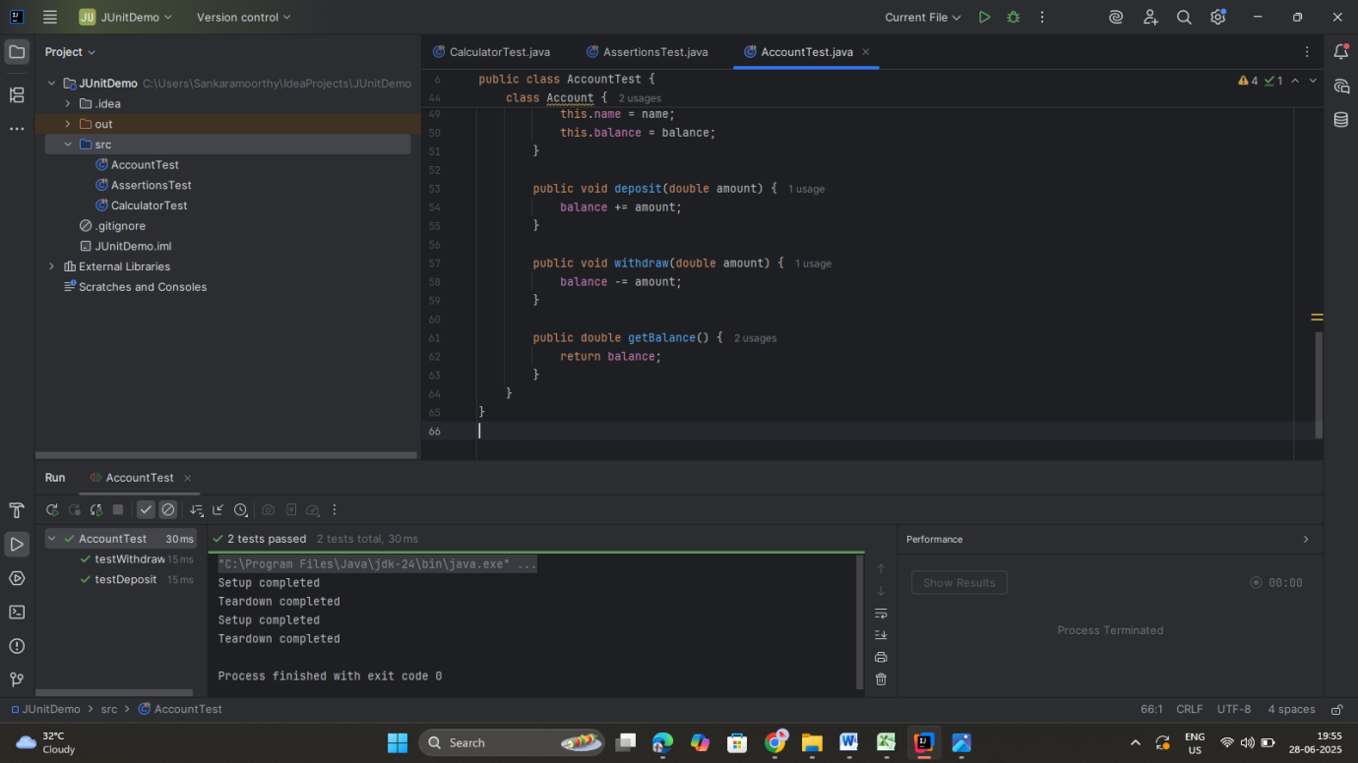

**Tools Used:**

* IntelliJ IDEA
* JUnit 5 (@BeforeEach, @Test, assertEquals())